**CST8257 Web Application Development**

Lab 2

# Objective

1. Understand the structures of PHP pages
2. How a PHP page is processed and how PHP scripts get input from web pages
3. How a PHP page creates its outputs

# Due Date

See Brightspace for the due date of this lab. To earn 5 points, you are required:

1. Complete the lab as required.
2. Submit your lab work to the Blackboard before the due date. Any late submission will have 2 points deducted automatically.
3. Demo me your lab work during the following week’s lab session. If for any reason, you miss a lab, you can make up the demo in a future lab session.

# Requirements

1. Create a HTML page, “DepositCalculator.html”.

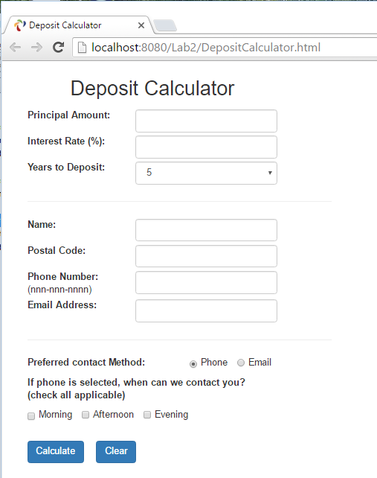

1. When “Calculate” button is clicked, the form should be submitted to a PHP page, “DepositCalculator.php”.
2. Write PHP page “DepositCalculator.php” which validate the data entered by the user according to the following rules:

* The user must enter data in all fields, no field can be blank.
* Principal Amount must be numeric and greater than zero.
* Interest Rate must be numeric and not negative.
* Number of years to deposit must be a numeric between 1 and 20.
* When a user select phone as his/her preferred contact method, he/she must select one or more contact times (morning, afternoon and/or evening).

For now, we will accept any non-blank string entered in the fields of postal code, phone or email as valid entries. We will learn how to validate a string against a particular format using Regular Express in our next lecture/lab.

1. If the submitted form fails to pass the validation, “DepositCalculator.php” display an error page to list all rule violations in the submitted form. For example if the user submitted a form with the data as show below:

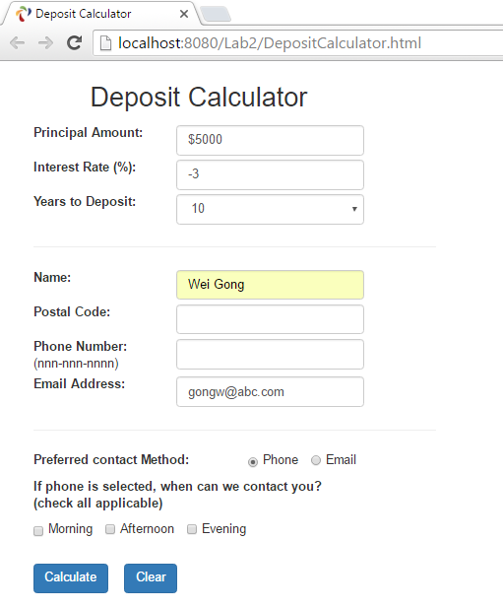

“DepositCalculator.php” will presents the user with following page:

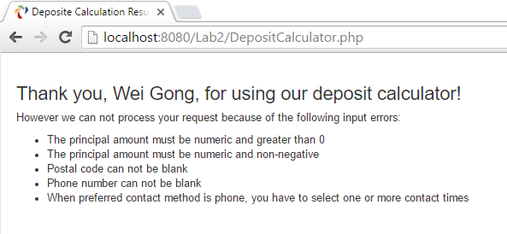

1. If the submitted form passes validation, “DepositCalculator.php” calculates the interest payment and the total amount for the number of years selected by the user and present the results to the user in a page similar to the following one:

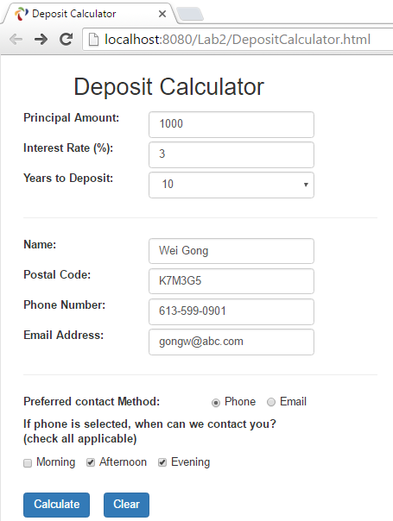

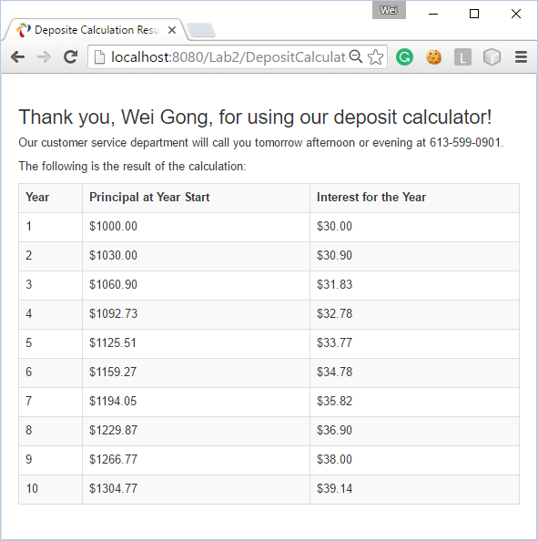

**Hints:**

* Use php built-in function trim( ) to remove leading and trailing blank from a string.
* Use function is_numeric( ) to check if an entered text string is a numeric string.
* Use function isset( ) to check if a variable has ever be assigned a value (a.k.a set).

For a checkbox (or a group of checkboxes), if none is checked, the corresponding variable in $_POST or $_GET will not be set.

* Use function printf( ) to format the monetary amount to the 2nd digits after decimal point.
* Although styling is not required for this lab, you are encouraged to try Bootstrap to style your page.

It’s a good time to start to learn Bootstrap <http://www.w3schools.com/bootstrap/>